EXP 10 – VIEW, INDEX
STUDENT TABLE
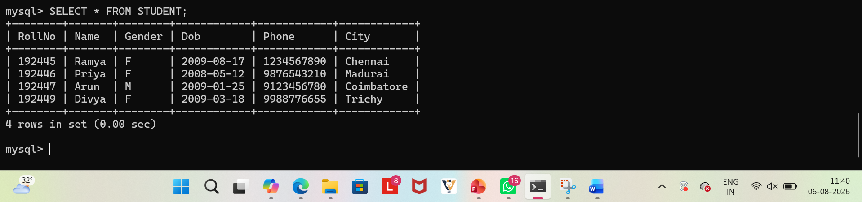
1.Create a view using student table which holds the Rollno , Name, city
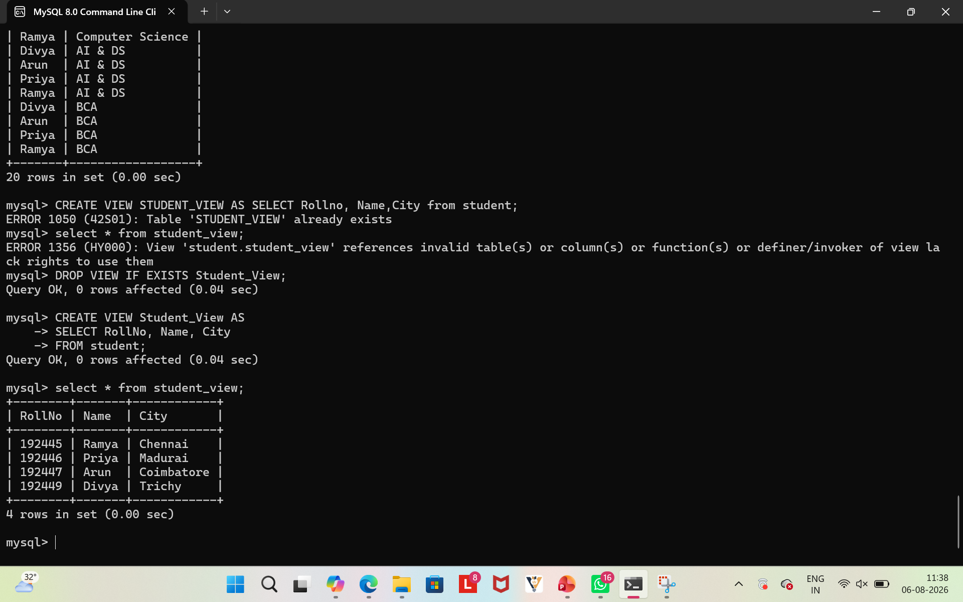
2.Index Name Ramya from student table
